**Class Activity – Lesson 16**

1. Did you attend class today (6 pts)
2. Were you on time to class today (3 pts)?
3. Create a pie chart and a bar graph using the date variable with class survey data using SPSS. What do you observe (2 pts)?

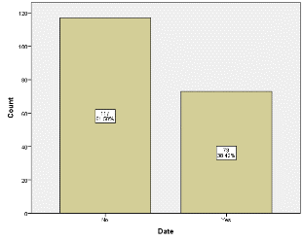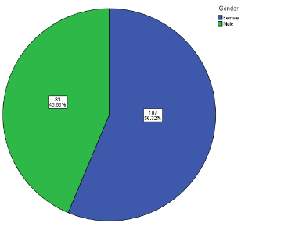

**The majority of students will not date against the height norm.**

1. Forty Percent is the true unknown percent of the college-aged population like Maroon Five (40% is *p*). Suppose a random sample of 500 college students is obtained. What is the probability that more than 180 college students in the survey like Maroon Five?
   1. (2 pts) What is the “mean” and standard deviation of the sampling distribution based on 500 students?

$μ_{\hat{p}}=p$**= 0.40 or 40%**

$σ_{\hat{p}}=\sqrt{\frac{p(1-p)}{n}}=\sqrt{\frac{0.4(1-0.4)}{500}}$**= 0.022 or 2.2%**

* 1. (2 pts) Check to see if we can apply the central limit theorem and assume that the distribution of $\hat{p}$ is normal.

**np=500*.4 = 200**

**n(1-p)=500*.6 = 300**

**Both results are greater than 10, so we can assume that the distribution of $\hat{p}$ is normal**

* 1. (2 pts.) Convert (standardize) the values of($\hat{p})$ using the standard normal variable Z (Find the Z-Score)
 $$Z=\frac{0.36-0.40}{\sqrt{\frac{0.4(1-0.4)}{500}}}=-1.826$$

 2. (2 pts.) Find the probability that more than 180 students in the survey like Maroon Five.

**Area = 0.9661**

